DA505 HOMEWORK 2 - FALL 2021

Oracle orcl Database HR Schema

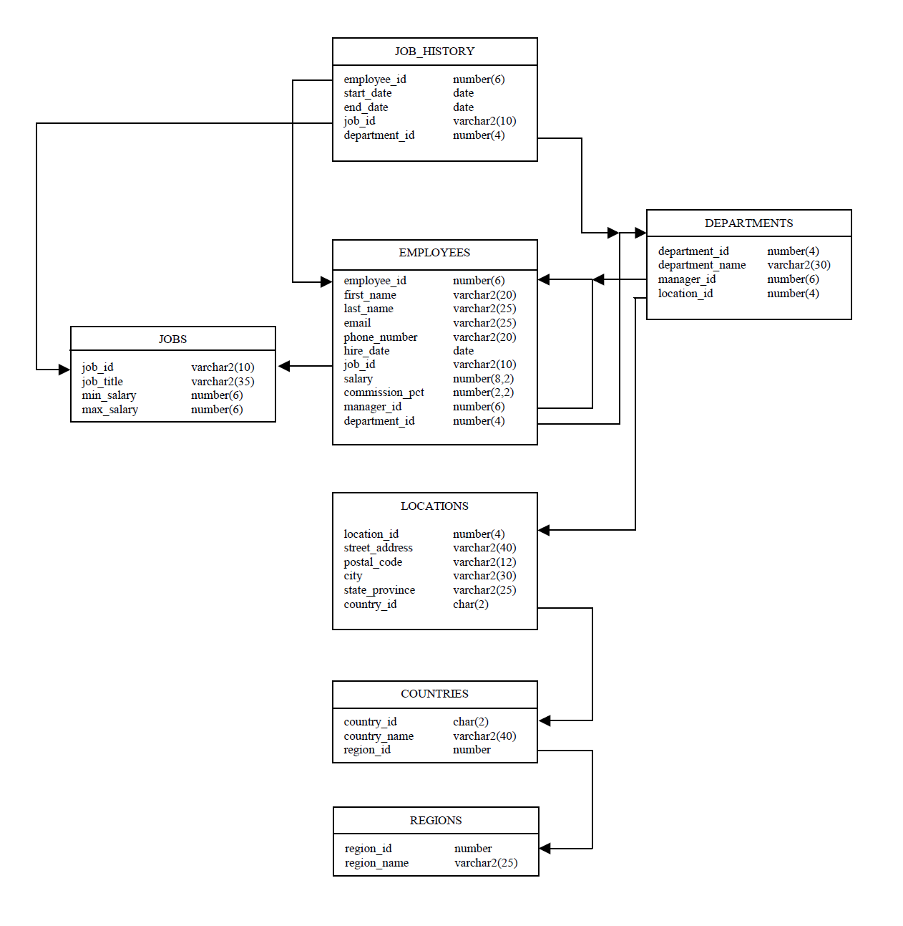

- Create a query that displays the EMPLOYEES’ last names, salaries and commission amounts. If an employee does not earn commission, put “No Commission.”

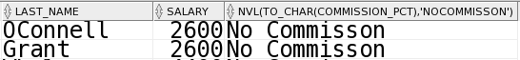

- Create a query that displays the EMPLOYEES’ last_names and their annual salaries. To calculate the annual salary, use the formula (salary*12)+(salary*12*commission_pct). Order the result by annual salary in descending order.
Hint: Use NVL function to avoid null results

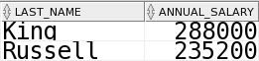

- Display the employee last name and department name for all EMPLOYEES who have an r (lowercase) in their last names. Show only the EMPLOYEES whose job_id is SA_MAN. Order the result by salary.

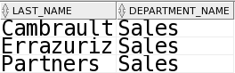

- Write a query to display the last name for all EMPLOYEES who work in Toronto.

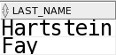

- Display the names, hire dates and salaries of all EMPLOYEES who were hired before their managers, along with their manager’s names and hire dates.
Hint: Use a self join

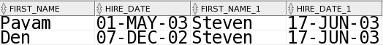

- Write a query to display the employee last name, department name and city of all EMPLOYEES who earn more than $5000.

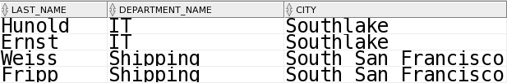

- Write a query to display the number of people with the same job.

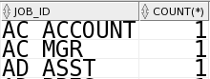

- Determine the number of managers without listing them. Label the column Number of Managers.
Hint: Use the distinct clause and MANAGER_ID column to determine the number of managers

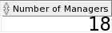

- Write a query that displays the difference between the highest and lowest salaries.

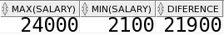

- Display the manager number and the SALARY of the lowest paid employee for that manager. Exclude anyone whose manager is not known. Exclude any groups where the minimum SALARY is $5,000 or less. Sort the output in descending order of SALARY.

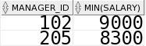

- Create a query that displays the employee last name, job title, department name and starting date for all jobs from 2001 to 2005.
Hint: Use to_char(colum_name,’YYYY’)

- The HR department needs a report for display the ID for those employees who did two or more jobs in the past.

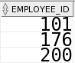

- Write a query in SQL to display the first and last name, and department number for those employees who holds a letter s as a 3rd character in their first name.

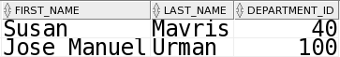

- Write a query to display the last name for all EMPLOYEES who work in Seattle or London.



- List the last_name and salary of employees who earn between $5000 and $12000, and are in department 20 or 50. Label the columns Employee and Monthly Salary.

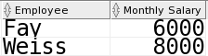

- Write a query to display the employee last name, department name, city and country of all EMPLOYEES who earn more than $7500.

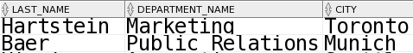

- Write a query to display the department number, department name, number of people with the same department and department avarage salary. Sort the output in descending order of avarage salary.

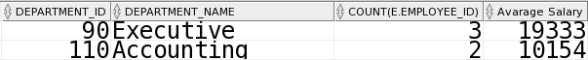

- List the employees who did not do any job in the past.

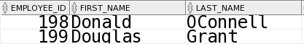

- Wirte a sql to find the city of employee whose employee ID is 107.

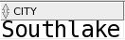

- Display first name, last_name, hire date and date of first salary of the employees.
Hint: Use a date function

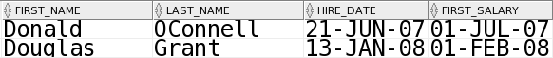

MySQL (sakila) / PostgreSQL (dvdrental) Database

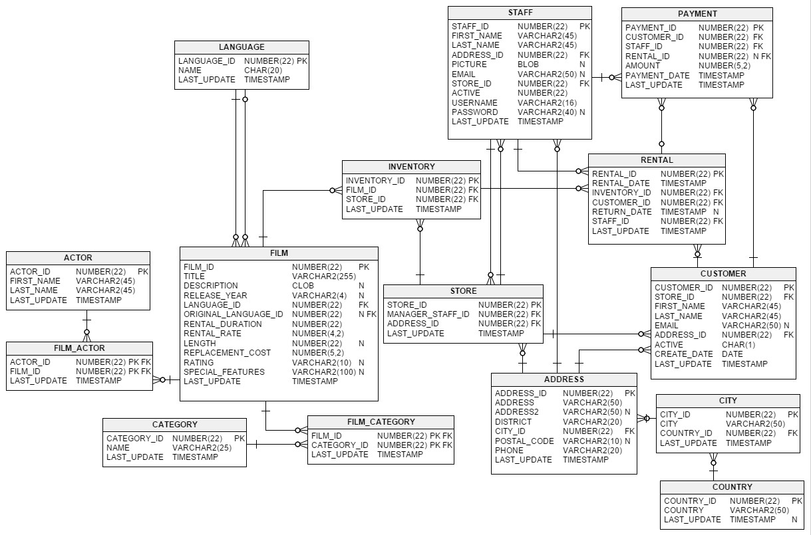

- Write a query to display actor first name, actor last name, film title and film category which films involve a ‘Cat’ and ‘Dog’.

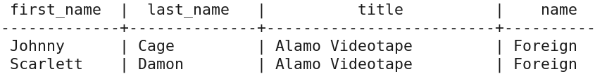

- Find the actor who has appeared in the most films?

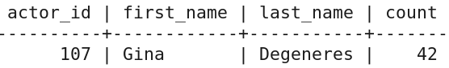

- Create a query to find countries with more than one city?

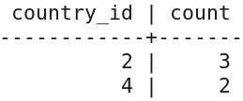

- List the number of actors first name and last name starts with same character?

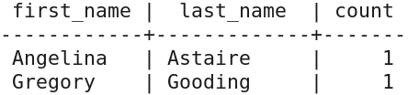

- Write a query to find how many movies are there in each language?

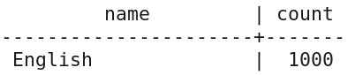

- Find the best customer based on number of rentals?

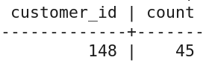
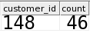

- Create a query to find the top 10 most common actor name?

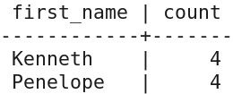

- Display the staff id, first name and last name who made more sales in 2007 April based on number of sales?
Hint : Use a date function (For PostgreSQL date_part, for MySQL datediff)

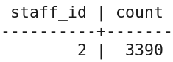
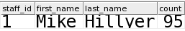

- Write a query to list how many customers returned the film only 1 days later then the rented day?

PostgreSQL: 1829
MySQL: 846

- Write a query to list the top 5 actor/actress first name and last name according to their number of movies?

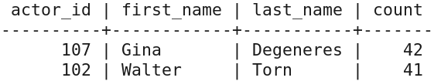

- Write a query to list rating and average rental rate of films whose rating R, G, PG or PG-13. List only average rating less than 3

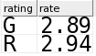

- Write a query to list actors and movies where the movie length was less than 50 minutes

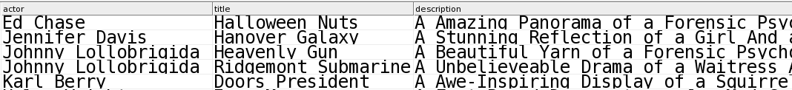

- Find the best customer (id, full name first name with last name) based on total payment?

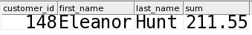
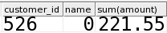

- List Top 10 film category name?

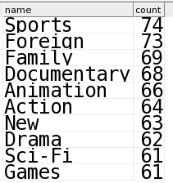

- Find the last names of actors, as well as how many actors have same last name?

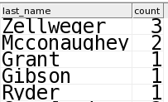

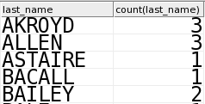

- Display the most frequently rented movies in descending order.

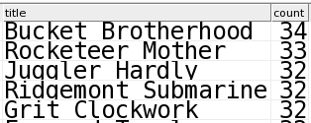

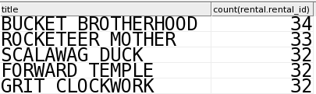

- Use subqueries to display all actors (first name, last name) who appear in the film Ridgemont Submarine.

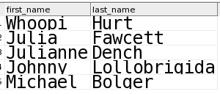

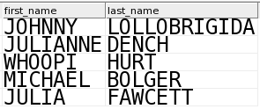

- Which movie has the longest rental duration in ‘Family’ category?

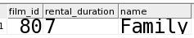

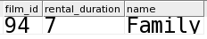

- How many Family category movies have rental_rate lower than 2?

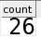

- Write a query that displays actor name, film title, length of movie, and "length category" that classifies movies based on their length (1 hour or less, Between 1-2 hours, Between 2-3 hours, More than 3 hours)

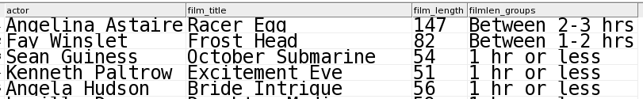

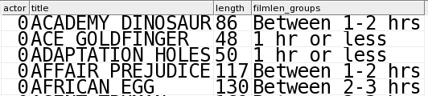

* Q - 11, 12, 18 Use job_history

Soru | Oracle | PostgreSQL | MySQL
1 | 107 | - | -
2 | 107 | - | -
3 | 3 | - | -
4 | 2 | - | -
5 | 37 | - | -
6 | 57/58 | - | -
7 | 19 | - | -
8 | 1 | - | -
9 | 1 | - | -
10 | 10 | - | -
11 | 4 | - | -
12 | 3 | - | -
13 | 5 | - | -
14 | 19 | - | -
15 | 6 | - | -
16 | 39 | - | -
17 | 11 | - | -
18 | 81 | - | -
19 | 1 | - | -
20 | 107 | - | -
21 | - | 921 | 921
22 | - | 1 | 1
23 | - | 67 | 67
24 | - | 11 | 11
25 | - | 1 | 1
26 | - | 1 | 1
27 | - | 10 | 10
28 | - | 1 | 1
29 | - | 1 | 1
30 | - | 5 | 5
31 | - | 2 | 2
32 | - | 149 | 149
33 | - | 1 | 1
34 | - | 10 | 10
35 | - | 121 | 121
36 | - | 10 | 10
37 | - | 5 | 5
38 | - | 1 | 1
39 | - | 1 | 1
40 | - | 10 | 10

* 57/58 INNER / LEFT JOIN

